**Guide to My-UI-Financials Reports**

**Log In to My-UI-Financials**

1. Go to [**My-UI-Financials**](https://myuifinancials.uillinois.edu/)**.** <https://myuifinancials.uillinois.edu/>
2. Enter your **NetID** and **Password**.
3. Click the **Login** button.

**Change Filters**

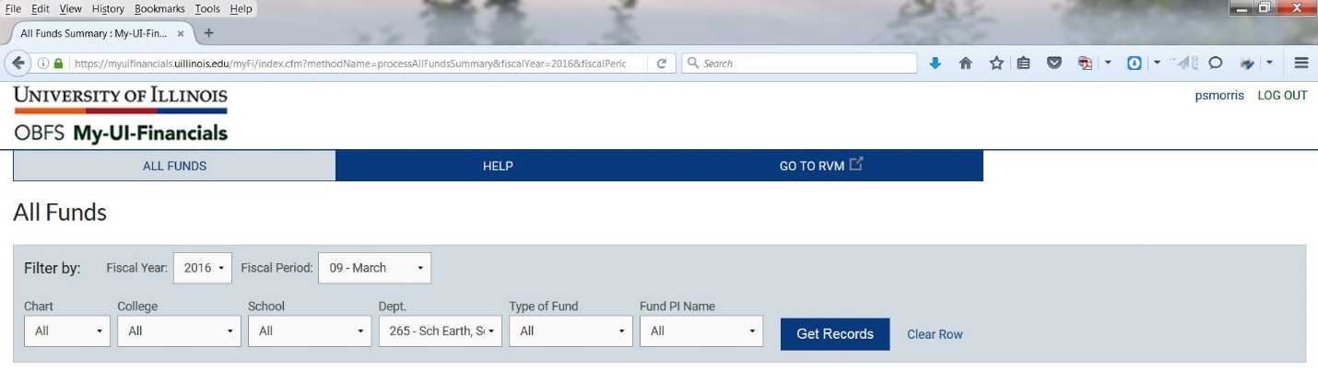

You can filter data by **Fiscal Year** and **Period.** You can also filter data by **Chart, College, School, Dept., Type of Fund,** and **Fund PI Name. These filters can be changed depending on the access granted for each person. Most users will only be able to see their own CFOPs.**

The dashboard defaults to the current open fiscal year and period (showing information through the prior day). Follow these steps to change to another fiscal year or period:

1. Select a year from the **Fiscal Year** dropdown list.
2. Select a month (period) from the **Fiscal Period** dropdown list.
3. Click the **Get Records** button.
4. Repeat steps 1 through 3 to filter by another Fiscal Year or Fiscal Period.

To filter by **Chart, College, School, Department (Dept.), Type of Fund** and **Fund Principal Investigator (Fund PI Name)** follow these steps:

1. In the menu for each filter, select the information you want to filter on and click the **Get Records** button
2. To reset the filters select **All** from the menu, and click the **Get Records** button or click **Clear** **Row** to reset all filters.

**NOTE:** Clicking **Clear Row** doesn't reset the Fiscal Year and Fiscal Period. Also, if you have multi-chart access you'll need to select **Chart** and **Dept** if there are duplicate instances of department codes, even though the department descriptions are different.

**Perform a Search**

You can search by **Fund, Organization,** and **Program** codes and **Title.**

1. Enter the search criteria in the **Search** field. As you enter criteria the dashboard results will narrow.
2. Delete the search criteria to clear the search field.

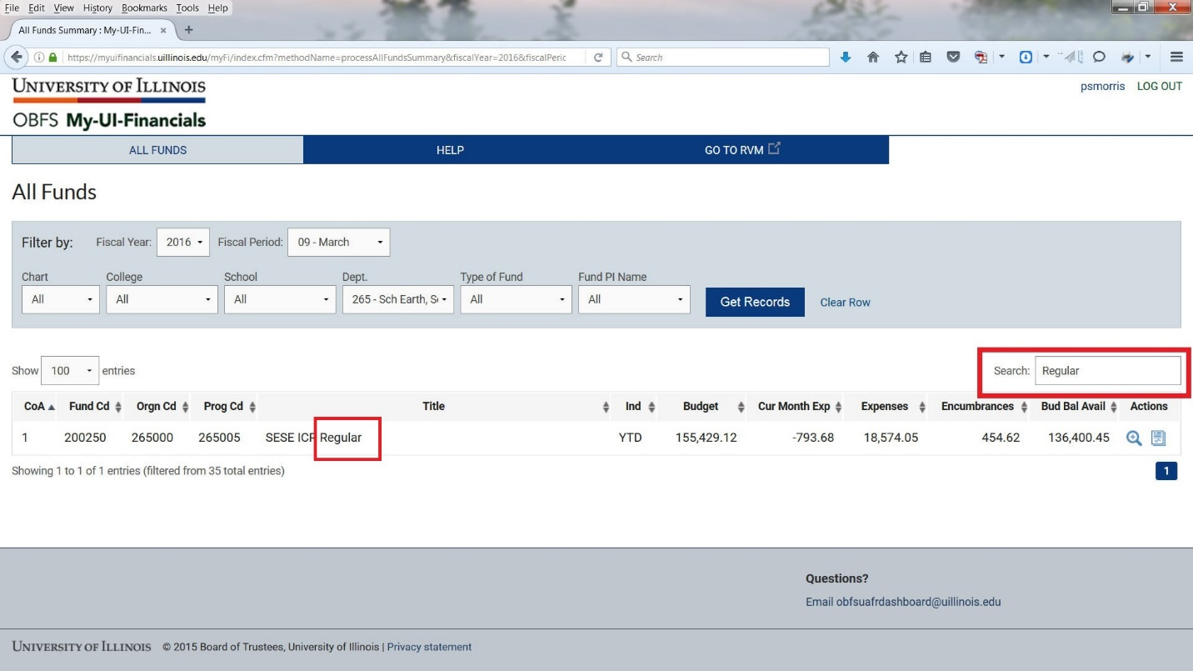

**View Data Details**

1. Click the **View details** icon under the **Actions** column for the desired CFOP to view Accounts by CFOP.

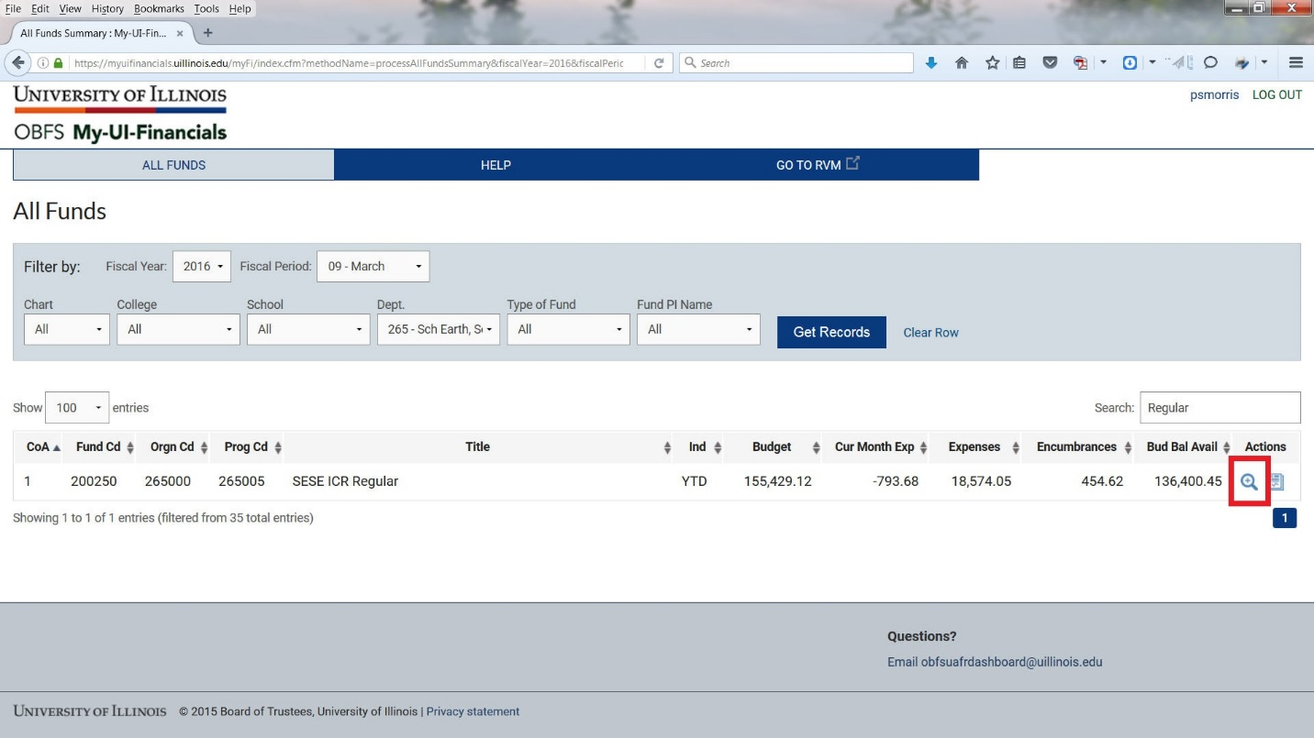

**Selecting View Details will return a breakdown by account code (revenue or expense category).**

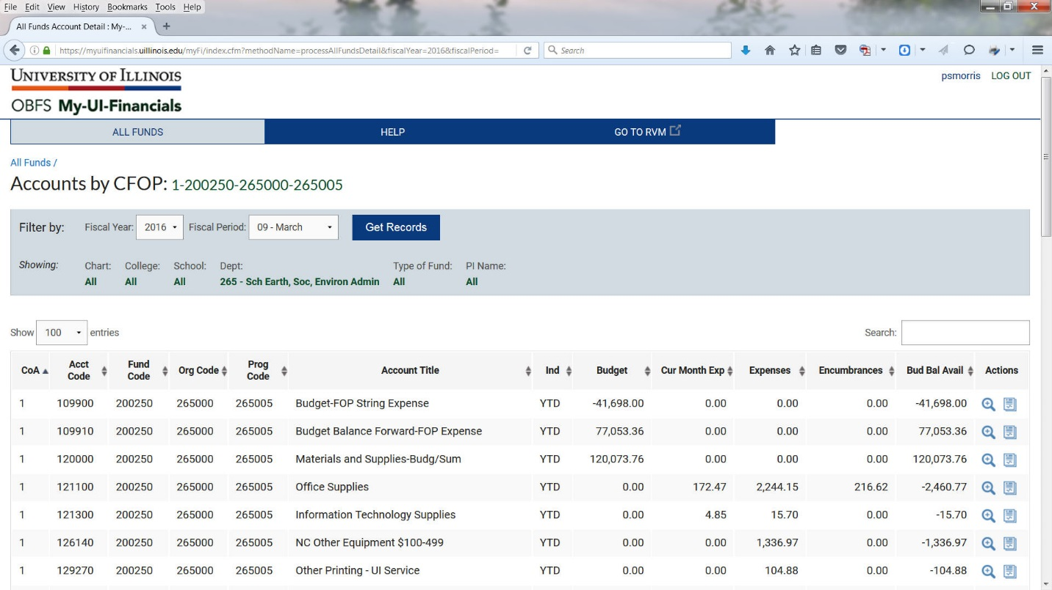

1. Click the **View Details** button under the **Actions** column for the desired account code to view the transactions. This will only work for lines that have a dollar amount under **“Cur Month Exp”.**

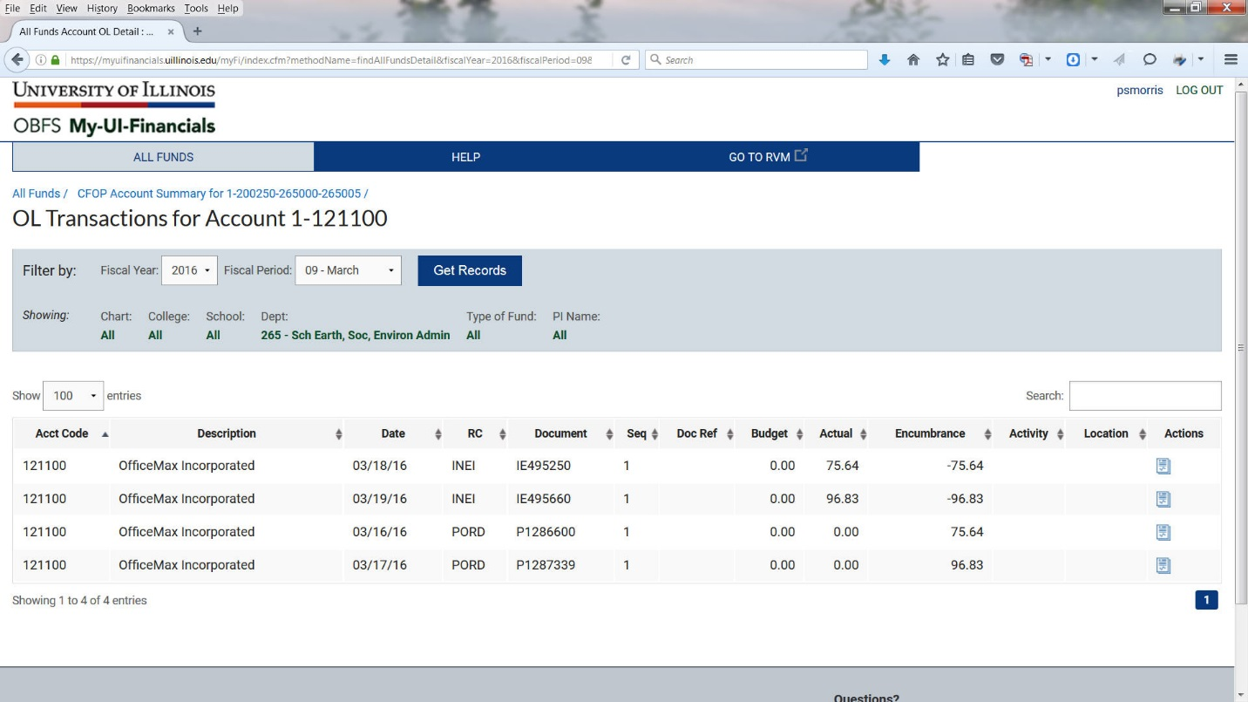

1. To return to the previous page, click the **CFOP Account Summary for** (breadcrumb at the top left) link. You will return to the Accounts by CFOP page and can view another account code. To return to your filtered results click on the **All Funds** (breadcrumbs at the top left) link where you can select another CFOP to view.

**Generate a Standard Report**

1. Select a fiscal year and period (month) from the **Fiscal Year:** and **Fiscal Period:** filters (if needed).
2. Click the **Report List** icon under the **Actions** column for the desired CFOP.
3. Select a report from the **Select a Report to Open** menu. The report will open in a new browser screen.

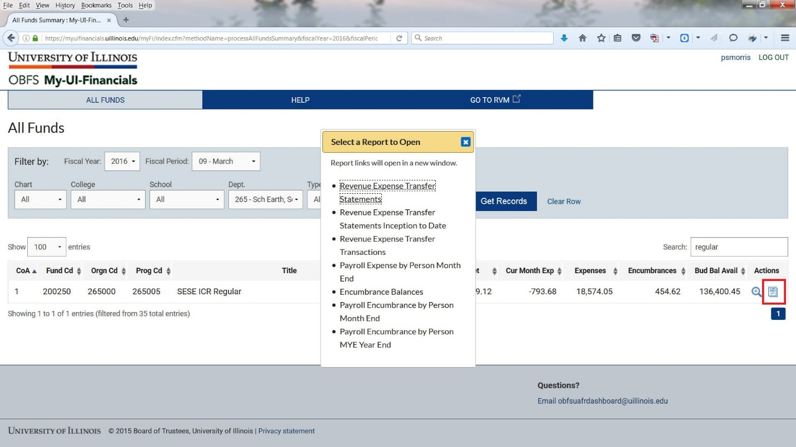

**What Report Should I Use?**

|  |  |
| --- | --- |
| **What report should I use to see...** | **Report Name** |
| To see my monthly transactions | Revenue Expense Transactions |
| To see my available balance for state, ICR, and gift funds | Revenue Expense Statements |
| To see my available balance for grant funds | Revenue Expense Statements Inception to Date |
| To see all my transactions for the fiscal year | Revenue Expense YTD Transactions by Account and Period |
| To see my available balance for self-supporting and service plan funds | Asset Liability Statements |
| To see last year’s self-supporting or service plan fund balance | Asset Liability Statements |
| To see my monthly payroll expenses | Payroll Expense by Person Month End |
| To see the details of my encumbrances | Encumbrance Balances |
| To see the details of my payroll encumbrances | Payroll Encumbrance by Person Month End |
| To see my multi-year payroll encumbrance on grant funds during year end | Payroll Encumbrance by Person MYE Year End |

**What Can I See With This Report?**

|  |  |
| --- | --- |
| **Report Name** | **What can I see with this report?** |
| Revenue Expense Transactions | Monthly transactions that can be compared with the unit’s own records for that month. |
| Revenue Expense Statements | Budget, expenses, encumbrances, and budget balance available for the fiscal year. |
| Revenue Expense Statements Inception to Date | Budget, expenses, encumbrances, and budget balance available since the beginning of a grant fund. |
| Revenue Expense YTD Transactions by Account and Period | Fiscal year-to-date activity showing budget, revenue, expenses, and encumbrances transactions grouped by account code & period. |
| Asset Liability Transactions | Monthly transactions involving cash, accounts receivable, accounts payable, as well as, other asset and liability account codes. |
| Asset Liability Statements | Balances of financial activity for a Fund, like cash, accounts receivable, accounts payables, fund balance, as well as, other asset and liability account codes. |
| Payroll Expense by Person Month End | Monthly payroll expenses by individual. |
| Encumbrance Balances | Details for non-payroll encumbrances such as original amount, payments, and remaining balance. |
| Payroll Encumbrance by Person Month End | Details for payroll encumbrances by individual. |
| Payroll Encumbrance by Person MYE Year End | Details for future year payroll encumbrances by individual on grant funds at fiscal year-end. |

**Exporting Data to Excel/CSV:**

My-UI-Financials data can be exported to Excel or CSV files. This is available for all screens. Select the **Export Data to:** button for the file type you wish to use. It can then be opened or saved to your computer. This can be helpful for viewing a summary of all of your existing CFOPs, or to select a specific CFOP and view a cleaner summary of its activities.

Note – If you plan to use the Excel export to do some planning for use of your funds, please remember that the export **Grand Totals** and **Budget Balance Available** are numbers and not calculations. These can be changed to formulas to perform calculations as needed in Excel. (Budget Balance Available **=** Budget **–** Expenses **–** Encumbrances)

**NOTES TO SESE USERS:**

**Access Manager** - The ability to add or revise who can access specific CFOPS in SESE Units is being administered by Scott Morris and Sherri Kiska. Please contact them if you have missing reports or wish for another person to see a specific CFOP.

**Monthly Financial Reports** – My-UI-Financials does not require manual adjustments at month end. Each month when Scott or Sherri receives a notice from the University that the prior month has been closed financially, an email will be sent out to the SESE Users asking them to log into My-UI-Financials and review transactions.